CS6364

Last Name: __________KONURI________

First Name: ____KEERTHI TEJA______________

NetID (UTD email): _______________kxk154530@utdallas.edu

Assignment #1 Due: 9/23 Wednesday

Submission: Submit (upload) softcopy (this doc file) via eLearning.
copy and paste (append) your part1 answers and part2 answers
at the end of this file and upload.

Note: You can upload the file(s) as many times as you need.
Note: Your file name should be:
cs6364 Assignment1 - Your last name, first name

Do not make any of these problems or your answers posted or available in Internet or do not share with any others. All of the assignment should be done by yourself.

For Lisp or Aima program, use dribble to start a log and to end it.
(dribble "part1.log") ;;; to start log
(dribble) ;;; to end log

Part 1 Lisp Exercise – 50%
#1 | #2 | #3 | #4 | #5 | #6 | #7 | #8 | #9 | #10 | Total

Part 2 AIMA Exercise – 50%
#1 | #2 | #3 | #4 | #5 | #6 | #7 | #8 | #9 | #10 | Total

Attach your answers for part1 and part2. Organize and present your documentation here professionally (to assist the grader/TA to save his or her time in grading, without searching your files and running codes beyond and above what is expected and reasonable).

LISP
1. What is the parenthesis notation for this cons cell structure?

(1)
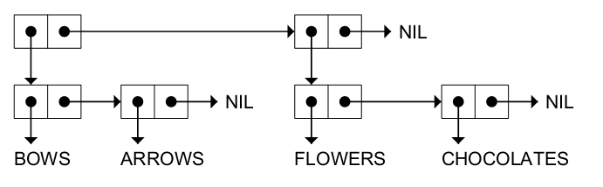

Answer: ((BOWS ARROWS) (FLOWERS CHOCOLATES))

(2)
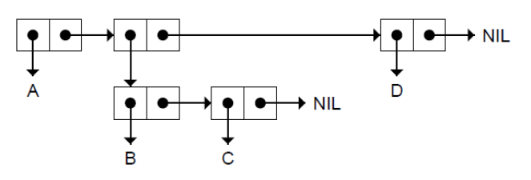

Answer: (A (B C)D)

(3)
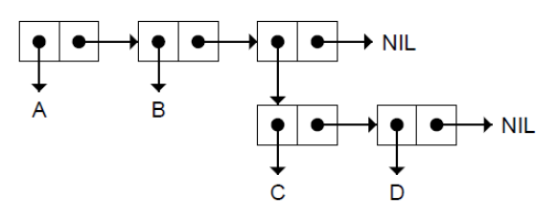

Answer: (A B (C D))

(4)
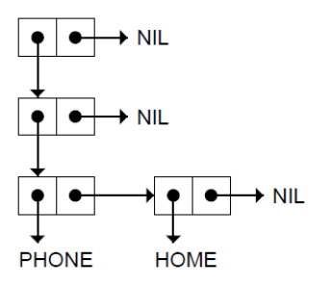

Answer: (((PHONE HOME)))
2. Draw the internal structure for the following list(s).

(1) (RED GREEN BLUE)

NIL
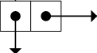
RED GREEN BLUE

(2) ((BLUE SKY) (GREEN GRASS) (BROWN EARTH))

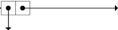
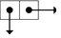
BLUE SKY GREEN GRASS BROWN EARTH

(3) ((BRAIN SURGEONS) NEVER (SAY OOPS))

NEVER
BRAIN SURGEONS SAY OOPS

(4) ((PHONE HOME))

PHONE HOME
3. Consider the following list, and answer the following questions. (FIRST List) = (CAR List)
(CDR List) = (Rest List)
((BLUE CUBE) (RED PYRAMID))
 | Initial List for each problem | ((BLUE CUBE) (RED PYRAMID))
1 | CDR | ((RED PYRAMID))
2 | CADR | (RED PYRAMID)
3 | CDADR | (PYRAMID)
4 | CADADR | PYRAMID
5 | CAR | (BLUE CUBE)

4. How many elements do each of the following lists have?
 |  | Answer
1 | (OPEN THE POD BAY DOORS HAL) | 6
2 | ((OPEN) (THE POD BAY DOORS) HAL) | 3
3 | ((1 2 3) (4 5 6) (7 8 9) (10 11 12)) | 4
4 | ((ONE) FOR ALL (AND (TWO (FOR ME)))) | 4
5 | ((Q SPADES)(7 HEARTS)(6 CLUBS)(5 DIAMONDS)(2 DIAMONDS)) | 5

5. What do each of the following expressions evaluate to?
Answer
 | Question | Answer
1  2  3  4  5  6  7 | (list ’cons t nil)  (eval (list ’cons t nil))  (eval (eval (list ’cons t nil)))  (apply #’cons ’(t nil))  (eval nil)  (list ’eval nil)  (eval (list ’eval nil)) | (CONS T NIL)  (T)  (T)  NIL  (EVAL NIL)  NIL

6. What is the result of the following Lisp expression?

 | (setf line ’(roses are red)) | Answer
1 | (reverse line) | (RED ARE ROSES)
2 | (first (last line)) | RED
3 | (nth 1 line) | ARE
4 | (reverse (reverse line)) | (ROSES ARE RED)
5 | (append line (list (first line))) | (ROSES ARE RED ROSES)
6 | (append (last line) line) | (RED ROSES ARE RED)
7 | (list (first line) (last line)) | (ROSES (RED))
8 | (cons (last line) line) | ((RED) ROSES ARE RED)
9 | (remove ’are line) | (ROSES RED)
10 | (append line ’(violets are blue)) | (ROSES ARE RED VIOLETS ARE BLUE)

7. What would be the (final) result of the following expression(s), or write a lambda expression for the expected result.

 | Problem | Result
1 | (defun add1 (n) (+ 1 n))  (mapcar #’add1 ’(1 3 5 7 9)) | (2 4 6 8 10)
2 | (mapcar #’zerop ’(2 0 3 4 0 -5 -6)) | (NIL T NIL NIL T NIL NIL)
3 | (mapcar #'null '(0 1 T NIL () T)) | (NIL NIL NIL T T NIL)
4 | Write a lambda expression to subtract seven from a number.
5 | Write a lambda expression that returns T if its input is T or NIL, but NIL for any other input.

8. What would be the result of the following expression(s)? Answer in T or NIL.

 | (setf x1 (list ’a ’b ’c))  (setf x2 (list ’a ’b ’c))  (setf z x1) | Answer
1 | (equal x1 x2)
2 | (eq x1 x2)
3 | (eq z x1)
4 | (eq z ’(a b c))
5 | (equal z ’(a b c))
6 | (eql ’foo ’foo)
7 | (eql 3 3.0)
8 | (= 3 3.0)
9 | (car NIL)
10 | (cdr NIL)

#9. Implement lisp function fib(n) to compute fibonacci number where fib(1) = 1, fib(2) = 1, and fib(n+2) = fib(n) + fib(n+1).
(a) Implement fib(n) using recursion

(b) Implement fib2(n) using tail-recursion with memory (to save the previous results).

10. Write a Lisp function to compute a factorial of n.
(1) Define a Lisp function factorial to compute factorial of n recursively (where n is a parameter).

(2) Define a Lisp function factorial2 with tail-recursion to compute Factorial of n (where n is a parameter).

(3) Define a Lisp function factorial3 to compute Factorial of n iteratively (where n is a parameter).

